Creating Hash Values

Project description

HASH
The following code demonstrates how I used Linux commands

- Compare the plain text of the two files presented for hashing
- Compute the sha256sum hash of the two separate files
- Compare the hashes provided to identify the differences

I used the”ls”command to list the contents of the directory.
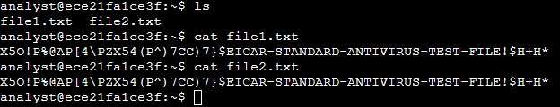
Two files,”file1.txt”and”file2.txt”, are listed. Use the”cat”command to display the contents of the”file1.txt”file

I Used the”sha256sum”command to generate the hash of the”file1.txt & 2
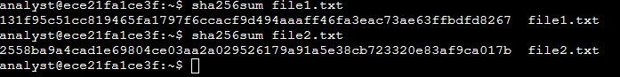
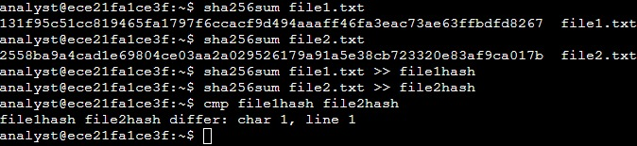
Next i Used the”sha256sum”command to generate the hash of the”file1.txt”file, and send the output to a new file called”file1hash”

I Used the”cmp”command to highlight the differences in the”file1hash”and”file2hash”

Summary
During this task, I successfully demonstrated proficiency in utilizing various command-line tools. Specifically, I utilized the ls command to list the contents of a directory, the cmp command to compare two hash values and determine their similarity, and the “cat command” to display the contents of a file.
By using the “ls command”, I efficiently obtained a comprehensive list of the files within the directory, specifically identifying the presence of "file1.txt" and "file2.txt". This command allowed me to gain a quick overview of the directory's contents.Furthermore, I effectively employed the cmp command to compare two hash values.
This comparison allowed me to ascertain whether the two files possessed identical or differing contents, providing valuable insights into their integrity and potential discrepancies.Lastly, I employed the “cat command” to display the contents of "file1.txt".
The output allowed for the easy visualization of the file's contents, providing an efficient means of reviewing and examining the data within.This exercise not only showcased my familiarity with essential command-line tools but also demonstrated my ability to apply them in a professional and efficient manner.
--Connor Gibson

